Milestone 2

COSC2299 Software Engineering: Process and Tools Semester 2

Due: 22/09/2020

**Project: HAPPY BOOKING**

Members: Amy Thompson (s3718266), Negar Farshchi (s3636862), Aleksander Pekaj (s3601291), Aldo Irvine (s3692192), Richard Dao (s3544270) and Shiou-Ping Chu (s3734303)



### Submission

<https://github.com/RMIT-SEPT/majorproject-4-wed-18-30-2>

<https://trello.com/b/Oi1rbDRt/agme>

<https://teams.microsoft.com/_#/school/conversations/LAB-WED-6.30-Ujj-Group2?threadId=19:743677e8f79643acb7ad93a47890f5ec@thread.tacv2&ctx=channel>

<https://drive.google.com/drive/folders/1zK3WYKvKdYJ3hqetu6mkNNfPBhLEtQru?usp=sharing>

<http://agme.com.s3-website.us-east-1.amazonaws.com/>

<https://app.circleci.com/projects/project-dashboard/github/RMIT-SEPT/>

<https://hub.docker.com/repository/docker/s3718266/agme>

Summary of New

We have added the new functionality of forgot password and a catalogue of all the services available. The forgot password feature was added to give our site some more functionality and to present closer to a deployable/usable site. The catalogue page was needed as the backend was wanting a way to display all the services available as an alternative option to picking a time and date. We have not added any new user stories as we completed these in the first milestone. This milestone we have worked on the connection of endpoints and getting the site deployed, as such we have quite a lot of new code. Some of the UI pages that have been created for this sprint is that of the dashboard, and fixing the login page. We have also created a new section in the backend for the booking functionality. As for the deployment, we have been working on the continuous integration of the UI which includes new code such as the Dockerfile. However currently it is not quite working correctly, although it is connected it returns errors. We have implemented CircleCI for testing as of now and are also returning errors.

Design Description Documentation

**Microservices Architecture**

Architecture design and layout of our application so far. This is due to change in the next milestone when we implement the continuous integration of the backend with micro services.

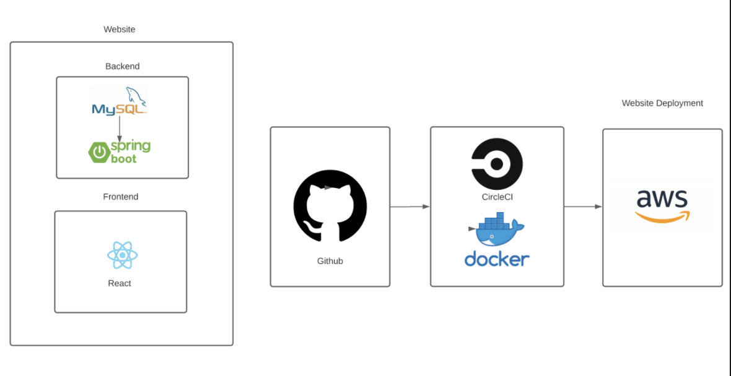

**Booking Class**

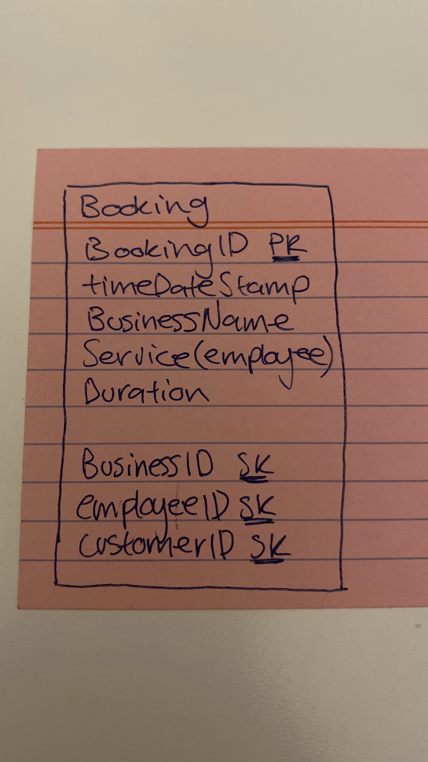

- user gets to the booking page by selecting a time from the calendar

- booking times are pre selected and show in the UI once the user has selected a time slot

- duration is automatically set to 30mins unless changed by the user

- in the UI you must select a business from a drop down list

- once the business has been chosen you can select from a drop down list of available services(employees) however this is not required for making a booking

- one business can have 0 to many bookings

- one booking can must have only one business

- one employee can have 0 to many bookings

- one booking can have 0 to 1 employees

- one customer can have 0 to many bookings

- one booking must have only 1 customer